d. Head of Revolutionary Council.

After the 1953 Iranian coup d'état, Pahlavi aligned Iran with the Western Bloc and cultivated a close relationship with the United States to consolidate his power as an authoritarian ruler. Relying heavily on American support amidst the Cold War, he remained the Shah of Iran for 26 years after the coup, effectively keeping the country from swaying towards the influence of the Eastern Bloc and the Soviet Union. [6][7] Beginning in 1963, Pahlavi implemented a number of reforms aimed at modernizing Iranian society, in what is known as the White Revolution. In light of his continued vocal opposition to the modernization campaign after being arrested twice, Khomeini was exiled from Iran in 1964. However, as major ideological tensions persisted between Pahlavi and Khomeini, anti-government. demonstrations began in October 1977, eventually developing into a campaign of civil resistance that included elements of secularism and Islamism. [8][9][10] In August 1978, the deaths of between 377 and 470 people in the Cinema Rex fire — claimed by the opposition as having been orchestrated by Pahlavi's SAVAK — came to serve as a catalyst for a popular. revolutionary movement across all of Iran,[11][12] and large-scale strikes and demonstrations paralyzed the entire country for the remainder of that year. On 16 January 1979, Pahlavi left the country and went into exile as the last Iranian monarch,[13] leaving behind his duties to Iran's Regency Council and Shapour Bakhtiar, the opposition-based Iranian prime minister. On 1 February 1979, Khomeini returned to Iran, following an invitation by the government;[6][14] several thousand Iranians gathered to greet him as he landed in the capital city of Tehran. [15] By 11 February 1979, the Khomeini assumed leadership over Iran while guerrillas and rebel troops overwhelmed Pahlavi loyalists in armed combat.[16][17] Following the March 1979 Islamic Republic referendum, in which 98% of Iranian voters approved the country's shift to an Islamic republic, the new government began efforts to draft the present-day Constitution of the Islamic Republic of Iran; [18][8][9][19][20] Khomeini emerged as the Supreme Leader of Iran in December 1979.[21]

The success of the Iranian Revolution was met with surprise around the world,[22] and was considered by many to be unusual in nature: it lacked many of the customary causes of revolutionary sentiment (e.g., defeat in war, a financial crisis, peasant rebellion, or disgruntled military);[23] occurred in a country that was experiencing relative prosperity;[6][20] produced profound change at great speed;[24] was massively popular; resulted in the massive exile that characterizes a large portion of today's Iranian diaspora; [25] and replaced a pro-Western secular[26] and authoritarian monarchy[6] with an anti-Western Islamist theocracy[6][19][20][27] that was based on the concept of Velâyat-e Faqih (or Guardianship of the Islamic Jurist), straddling between authoritarianism and totalitarianism. [28] In addition to these, the Iranian Revolution sought the spread of Shia Islam across the Middle East through the ideological tenets of Khomeinism — particularly as a means of uprooting the region's status quo, which favoured Sunni Islam. [29] After the consolidation of Khomeinist factions, Iran began to back Shia militancy across the region in an attempt to combat Sunni influence and establish Iranian dominance within the Arab world, ultimately aiming to achieve an Iranian-led Shia political order. [30]

6. Other shortcomings of the previous regime.

The Shah's regime was seen as an oppressive, brutal,[35][36] corrupt, and lavish regime by some of the society's classes at that time.[35][37] It also suffered from some basic functional failures that brought economic bottlenecks, shortages, and inflation. [38] The Shah was perceived by many as beholden to—if not a puppet of—a non-Muslim Western power (i.e., the United States) [39][40] whose culture was affecting that of Iran. At the same time, support for the Shah may have waned among Western politicians and media—especially under the administration of U.S. President Jimmy Carter—as a result of the Shah's support for OPEC petroleum price increases earlier in the decade.[41] When President Carter enacted a human-rights policy which said that countries guilty of human-rights violations would be deprived of American arms or aid, this helped give some Iranians the courage to post open letters and petitions in the hope that the repression by the government might subside.[42]

The Revolution that substituted the monarchy of Mohammad Reza Shah Pahlavi with Islam and Khomeini is credited in part to the spread of the Shi'a version of the Islamic revival. It resisted westernization and saw Ayatollah Khomeini as following in the footsteps of the Shi'a Imam Husayn ibn Ali, with the Shah playing the role of Husayn's foe, the hated tyrant Yazid I. [43] Other factors include the underestimation of Khomeini's Islamist movement by both the Shah's reign—who considered them a minor threat compared to the Marxists and Islamic socialists[44][45][46]—and by the secularist opponents of the government— who thought the Khomeinists could be sidelined.[47]

Tobacco Protest (1891)

At the end of the 19th century, the Shi'a clergy (ulama) had a significant influence on Iranian society. The clergy first showed itself to be a powerful political force in opposition to the monarchy with the 1891 Tobacco Protest. On 20 March 1890, the long-standing Iranian monarch Nasir al-Din Shah granted a concession to British Major G. F. Talbot for a full monopoly over the production, sale, and export of tobacco for 50 years.[48] At the time, the Persian tobacco industry employed over 200,000 people, so the concession represented a major blow to Persian farmers and bazaaris whose livelihoods were largely dependent on the lucrative tobacco business.[49] The boycotts and protests against it were widespread and extensive as result of Mirza Hasan Shirazi's fatwa (judicial decree).[50] Within 2 years, Nasir al-Din Shah found himself powerless to stop the popular movement and cancelled the concession.[51]

The Tobacco Protest was the first significant Iranian resistance against the Shah and foreign interests, revealing the power of the people and the ulama influence among them.[48]

Persian Constitutional Revolution (1905–1911)

The growing dissatisfaction continued until the Constitutional Revolution of 1905–1911. The revolution led to the establishment of a parliament, the National Consultative Assembly (also known as the Majlis), and approval of the first constitution. Although the constitutional revolution was successful in weakening the autocracy of the Qajar regime, it failed to provide a powerful alternative government. Therefore, in the decades following the establishment of the new parliament, a number of critical events took place. Many of these events can be viewed as a continuation of the struggle between the constitutionalists and the Shahs of Persia, many of whom were backed by foreign powers against the parliament.

Reza Shah (1921–1935)

Insecurity and chaos created after the Constitutional Revolution led to the rise of General Reza Khan, the commander of the elite Persian Cossack Brigade who seized power in a coup d'état in February 1921. He established a constitutional monarchy, deposing the last Qajar Shah, Ahmed Shah, in 1925 and being designated monarch by the National Assembly, to be known thenceforth as Reza Shah, founder of the Pahlavi dynasty. There were widespread social, economic, and political reforms introduced during his reign, a number of which led to public discontent that would provide the circumstances for the Iranian Revolution. Particularly controversial was the replacement of Islamic laws with Western ones and the forbidding of traditional Islamic clothing, separation of the sexes, and veiling of women's faces with the niqab. [52] Police forcibly removed and tore chadors off women who resisted his ban on the public hijab. In 1935, dozens were killed and hundreds injured in the Goharshad Mosque rebellion. [53][54][55] On the other hand, during the early rise of Reza Shah, AbdulKarim Ha'eri Yazdi founded the Qom Seminary and created important changes in seminaries. However, he would avoid entering into political issues, as did other religious leaders who followed him. Hence, no widespread anti-government attempts were organized by clergy during the rule of Reza Shah. However, the future Ayatollah Khomeini was a student of Sheikh Abdul Karim Ha'eri.[56]

Mosaddegh and The Anglo-Iranian Oil Company (1951–1952)

From 1901 on, the Anglo-Persian Oil Company (renamed the Anglo-Iranian Oil Company in 1931), a British oil company, enjoyed a monopoly on sale and production of Iranian oil. It was the most profitable British business in the world.[57] Most Iranians lived in poverty while the wealth generated from Iranian oil played a decisive role in maintaining Britain at the top of the world. In 1951, Iranian Prime Minister Mohammad Mosaddegh pledged to throw the company out of Iran, reclaim the petroleum reserves and free Iran from foreign powers. In 1952, Mosaddegh nationalized the Anglo-Iranian Oil Company and became a national hero. The British, however, were outraged and accused him of stealing. The British unsuccessfully sought punishment from the World Court and the United Nations, sent warships to the Persian Gulf, and finally imposed a crushing embargo. Mosaddegh was unmoved by Britain's campaign against him. One European newspaper, the Frankfurter Neue Presse, reported that Mosaddegh "would rather be fried in Persian oil than make the slightest concession to the British." The British considered an armed invasion, but UK Prime Minister Winston Churchill decided on a coup after being refused American military support by U.S. President Harry S. Truman, who sympathized with nationalist movements like Mosaddegh's and had nothing but contempt for old-style imperialists like those who ran the AngloIranian Oil Company. Mosaddegh, however, learned of Churchill's plans and ordered the British embassy to be closed in October 1952, forcing all British diplomats and agents to leave the country. Although the British were initially turned down in their request for American support by President Truman, the election of Dwight D. Eisenhower as U.S. president in November 1952 changed the American stance toward the conflict. On 20 January 1953, U.S. Secretary of State John Foster Dulles and his brother, C.I.A. Director Allen Dulles, told their British counterparts that they were ready to move against Mosaddegh. In their eyes, any country not decisively allied with the United States was a potential enemy. Iran had immense oil wealth, a long border with the Soviet Union, and a nationalist prime minister. The prospect of a fall into communism and a "second China" (after Mao Zedong won the Chinese Civil War) terrified the Dulles brothers. Operation Ajax was born, in which the only democratic government Iran ever had was deposed. [58]

Iranian coup d'état (1953)

In 1941, an invasion of allied British and Soviet troops deposed Reza Shah, who was considered friendly to Nazi Germany, and installed his son, Mohammad Reza Pahlavi as Shah. In 1953, following the nationalization of the Iranian oil industry by the democratically elected prime minister Mohammad Mossadegh, American and British forces instituted a highly effective embargo of Iranian oil, and covertly destabilized the legislature and helped return control to their ally, Pahlavi. The American "Operation Ajax", orchestrated by the CIA, was aided by the British MI6 in organizing a military coup d'état to oust Mossadegh. The Shah fled to Italy when the initial coup attempt on August 15 failed, but returned after a successful second attempt on August 19.[59]

Pahlavi maintained a close relationship with the U.S. government, as both regimes shared opposition to the expansion of the Soviet Union, Iran's powerful northern neighbor. Like his father, the Shah's government was known for its autocracy, its focus on modernization and Westernization, and for its disregard for religious and democratic measures in Iran's constitution. Leftist and Islamist groups attacked his government (often from outside Iran as they were suppressed within) for violating the Iranian constitution, political corruption, and the political oppression, torture, and killings, by the SAVAK secret police.

White Revolution (1963–1978)

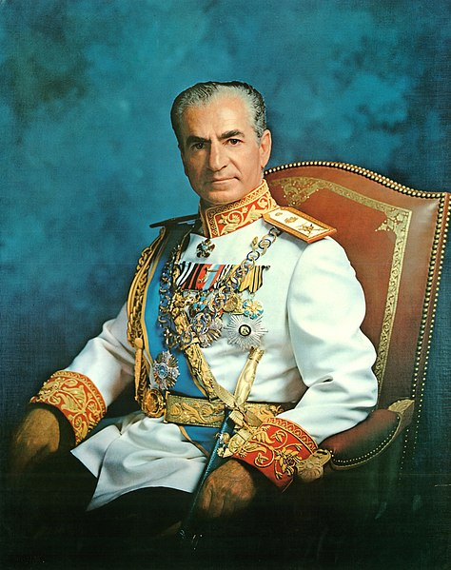

Shah Mohammad Reza Pahlavi

The White Revolution was a far-reaching series of reforms in Iran launched in 1963 by Shah Mohammad Reza Pahlavi and lasted until 1978. Mohammad Reza Shah's reform program was built especially to weaken those classes that supported the traditional system. It consisted of several elements including land reform; sales of some state-owned factories to finance the land reform; the enfranchisement of women; nationalization of forests and pastures; formation of a literacy corps; and the institution of profit-sharing schemes for workers in industry. [60]

The Shah advertised the White Revolution as a step towards westernization, [61] and it was a way for him to legitimize the Pahlavi dynasty. Part of the reason for launching the White Revolution was that the Shah hoped to get rid of the influence of landlords and to create a new base of support among the peasants and working class.[62][63] Thus, the White Revolution in Iran was an attempt to introduce reform from above and preserve traditional power patterns. Through land reform, the essence of the White Revolution, the Shah hoped to ally himself with the peasantry in the countryside and hoped to sever their ties with the aristocracy in the city.

What the Shah did not expect, however, was that the White Revolution led to new social tensions that helped create many of the problems the Shah had been trying to avoid. The Shah's reforms more than quadrupled the combined size of the two classes that had posed the most challenges to his monarchy in the past— the intelligentsia and the urban working class. Their resentment towards the Shah also grew as they were now stripped of organizations that had represented them in the past, such as political parties, professional associations, trade unions, and independent newspapers. The land reform, instead of allying the peasants with the government, produced large numbers of independent farmers and landless laborers who became loose political cannons, with no feeling of loyalty to the Shah. Many of the masses felt resentment towards the increasingly corrupt government; their loyalty to the clergy, who were seen as more concerned with the fate of the populace, remained consistent or increased. As Ervand Abrahamian pointed out: "The White Revolution had been designed to preempt a Red Revolution. Instead, it paved the way for an Islamic Revolution." [64] The White Revolution's economic "trickle-down" strategy also did not work as intended. In theory, oil money funneled to the elite was supposed to be used to create jobs and factories, eventually distributing the money, but instead the wealth tended to get stuck at the top and concentrated in the hands of the very few. [65]

Western culture was a plague or an intoxication to be eliminated;[70] Ali Shariati's vision of Islam as the one true liberator of the Third World from oppressive colonialism, neo-colonialism, and capitalism; [71] and Morteza Motahhari's popularized retellings of the Shia faith all spread and gained listeners, readers and supporters.[70]

Most importantly, Khomeini preached that revolt, and especially martyrdom, against injustice and tyranny was part of Shia Islam,[72] and that Muslims should reject the influence of both liberal capitalism and communism, ideas that inspired the revolutionary slogan "Neither East, nor West – Islamic Republic!"

Away from public view, Khomeini developed the ideology of velayat-e faqih (guardianship of the jurist) as government, that Muslims—in fact everyone—required "guardianship," in the form of rule or supervision by the leading Islamic jurist or jurists.[73] Such rule was ultimately "more necessary even than prayer and fasting" in Islam,[Note 2] as it would protect Islam from deviation from traditional sharia law and in so doing eliminate poverty, injustice, and the "plundering" of Muslim land by foreign non-believers.[74]

This idea of rule by Islamic jurists was spread through his book Islamic Government, mosque sermons, and smuggled cassette speeches by Khomeini [75][76] among his opposition network of students (talabeh), ex-students (able clerics such as Morteza Motahhari, Mohammad Beheshti, Mohammad-Javad Bahonar, Akbar Hashemi Rafsanjani, and Mohammad Mofatteh), and traditional businessmen (bazaari) inside Iran.[75] cohesion and organization of Khomeini's forces.[79]

Communist groups—primarily the Tudeh Party of Iran and the Fedaian guerrillas [Note 3]—had been weakened considerably by government repression. Despite this the guerrillas did help play an important part in the final February 1979 overthrow [81] delivering "the regime its coup de grace." [82] The most powerful guerrilla group—the People's Mujahedin— was leftist Islamist and opposed the influence of the clergy as reactionary.

Some important clergy did not follow Khomeini's lead. Popular ayatollah Mahmoud Taleghani supported the left, while perhaps the most senior and influential ayatollah in Iran—Mohammad Kazem Shariatmadari—first remained aloof from politics and then came out in support of a democratic revolution.[83]

Khomeini worked to unite this opposition behind him (except for the unwanted 'atheistic Marxists'),[8][84] focusing on the socio-economic problems of the Shah's government (corruption and unequal income and development),[8][85] while avoiding specifics among the public that might divide the factions[86]—particularly his plan for clerical rule, which he believed most Iranians had become prejudiced against as a result of propaganda campaign by Western imperialists. [Note 4][87]

In the post-Shah era, some revolutionaries who clashed with his theocracy and were suppressed by his movement complained of deception,[85] but in the meantime antiShah unity was maintained. [88]

1970–1977

Several events in the 1970s set the stage for the 1979 revolution. The 1971 2,500-year celebration of the Persian Empire at Persepolis, organized by the government, was attacked for its extravagance. "As the foreigners reveled on drink forbidden by Islam, Iranians were not only excluded from the festivities, some were starving." [89] Five years later, the Shah angered pious Iranian Muslims by changing the first year of the Iranian solar calendar from the Islamic hijri to the ascension to the throne by Cyrus the the Shah's family was the foremost beneficiary of the income generated by oil, and the line between state earnings and family earnings blurred. By 1976, the Shah had accumulated upward of $1 billion from oil revenue; his family – including 63 princes and princesses had accumulated between $5 and $20 billion; and the family foundation controlled approximately $3 billion.[92] By mid-1977 economic austerity measures to fight inflation disproportionately affected the thousands of poor and unskilled male migrants settling in the cities working in the construction industry. Culturally and religiously conservative,[93] many went on to form the core of the revolution's demonstrators and "martyrs".[94]

All Iranians were required to join and pay dues to a new political party, the Ḥezb-e Rastakhiz party—all other parties were banned.[95] That party's attempt to fight inflation with populist "anti-profiteering" campaigns—fining and jailing merchants for high prices – angered and politicized merchants while fueling black markets. [96]

In 1977 the Shah responded to the "polite reminder" of the importance of political rights by the new American president, Jimmy Carter, by granting amnesty to some prisoners and allowing the Red Cross to visit prisons. Through 1977 liberal opposition formed organizations and issued open letters denouncing the government.[97] Against this background a first crucial manifestation of public expression of social discontent and political protest against the regime took place in October 1977, when the GermanIranian Cultural Association in Tehran hosted a series of literature reading sessions, organized by the newly revived Iranian Writers Association and the German Goethe-Institute.

In these "Ten Nights" (Dah Shab) 57 of Iran's most prominent poets and writers read their The chain of events began with the death of Mostafa Khomeini, chief aide and eldest son of Ruhollah Khomeini. He mysteriously died at midnight on 23 October 1977 in Najaf, Iraq. SAVAK and the Iraqi government declared heart attack as the cause of death, though many believed his death was attributed to SAVAK.[103] Khomeini remained silent after the incident, while in Iran with the spread of the news came a wave of protest and mourning ceremonies in several cities.[104][105] The mourning of Mostafa was given a political cast by Khomeini's political credentials, their enduring opposition to the monarchy and their exile. The developments initiated by seminaries closing on 7 January 1978 were followed by the bazaar and seminary closing, and students rallied towards the homes of the religious leaders on the next day. [106] On 9 January 1978, seminary students and other people demonstrated in the city, which was cracked down by the Shah's security forces who shot live ammunition to disperse the crowd when the peaceful demonstration turned violent.[107] Between 5–300 of the demonstrators were reportedly killed in the protest.[106] 9 January 1978 (19 Dey) is regarded as a bloody day in Qom.[108][109]

Consolidation of the opposition (February–March)

According to Shia customs, memorial services (chehelom) are held 40 days after a person's death.[110] Encouraged by Khomeini (who declared that the blood of martyrs must water the "tree of Islam"),[102] radicals pressured the mosques and moderate clergy to commemorate the deaths of the students, and used the occasion to generate protests.[111] The informal network of mosques and bazaars, which for years had been used to carry out religious events, increasingly became where protests were larger, and Tehran, where they were smaller—protesting every 40 days. This amounted to a small minority of the more than 15 million adults in Iran.[119]

Against the wishes of Khomeini, Shariatmadari called for 17 June mourning protests to be carried out as a one-day stay. [110] Although tensions remained in the milieu, the Shah's policy appeared to have worked, leading Amuzegar to declare that "the crisis is over." A CIA analysis in August concluded that Iran "is not in a revolutionary or even a pre-revolutionary situation." [120] These and later events in

Renewed protests (August– September)

Appointment of Jafar Sharif-Emami as prime minister (11 August)

By August, the protests had "kick[ed]…into high gear, " [122] and the number of demonstrators mushroomed to hundreds of thousands.[119] In an attempt to dampen inflation, the Amuzegar administration cut spending and reduced business. However, the cutbacks led to a sharp rise in layoffs— particularly among young, unskilled, male workers living in the working-class districts. By summer 1978, the working The protesters demanded that Shah Mohammad Reza Pahlavi step down from power and that Grand Ayatollah Ruhollah Khomeini be returned from exile. The protests grew incredibly fast, reaching between six million and nine million in strength in the first week. About 5% of the population had taken to the streets in the Muharram protests. Both beginning and ending in the month of Muharram, the protests succeeded, and the Shah stepped down from power later that month.[137]

After the success of what would become known as a revolution, Ayatollah Khomeini returned to Iran as its religious and political leader for life. Khomeini had been an opposition leader to Shah for many years, rising to prominence after the death of his mentor, renowned scholar Yazdi Ha'iri, in the 1930s. [138] Even in his years in exile, Khomeini remained relevant in Iran. Supporting the protests from beyond Iran's borders, he proclaimed that "freedom and liberation from the bonds of imperialism" was imminent.[138]

Tasu'a and Ashura marches (10–11 December)

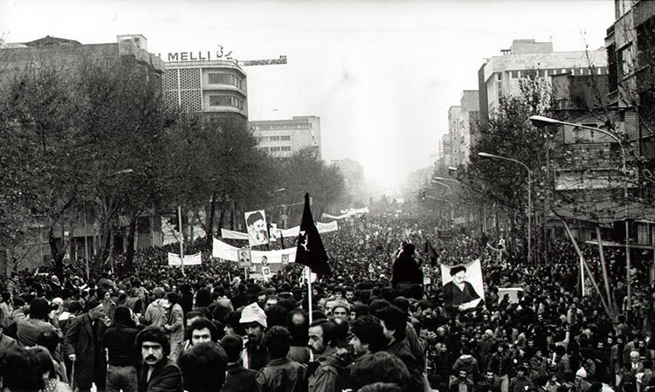

Tehran Ashura demonstration, 11 December 1978

As the days of Tasu'a and Ashura (10 and 11 December) approached, in order to prevent a deadly showdown the Shah began to draw back. In negotiations with Ayatollah Shariatmadari, the Shah ordered the release of 120 political prisoners and Karim Sanjabi, and on 8 December revoked the ban on street demonstrations. Permits Tehran Ashura demonstration, 11 December 1978 were issued for the marchers, and troops were removed from the procession's path. In turn, Shariatmadari pledged that to make sure that there would be no violence during the demonstrations.[112]

On 10 and 11 December 1978, the days of Tasu'a and Ashura, between 6 and 9 million anti-Shah demonstrators marched throughout Iran. According to one historian, "even discounting for exaggeration, these figures may represent the largest protest event in history." [139] The marches were led by Ayatollah Taleghani and National Front leader Karim Sanjabi, thus symbolizing the "unity" of the secular and religious opposition. The mullahs and bazaaris effectively policed the gathering, and protesters who attempted to initiate violence were restrained.[110]

More than 10% of the country marched in anti-Shah demonstrations on the two days, possibly a higher percentage than any previous revolution. It is rare for a revolution to involve as much as 1 percent of a country's population; the French, Russian, and Romanian revolutions may have passed the 1 percent mark.[25]

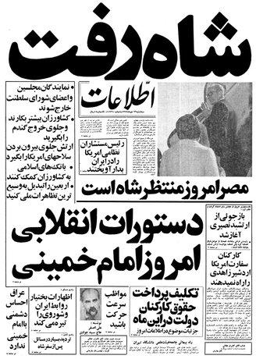

The Shah is Gone — headline of

Iranian newspaper Ettela'at, 16

January 1979, when the last monarch

of Iran left the country

Revolution (late 1978–1979)

Much of Iranian society was in euphoria about the coming revolution. Secular and leftist politicians piled onto the movement hoping to gain power in the aftermath, ignoring the fact that Khomeini was the very antithesis to all of the positions they supported.[6] While it was increasingly Revolution (late 1978–1979) clear to more secular Iranians that Khomeini was not a liberal, he was widely perceived as a figurehead, and that power would eventually be handed to the secular groups.[6][117]

Demoralization of the army (December ,1978)

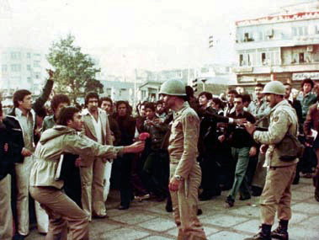

A protester giving flowers to an army officer.

The military leadership was increasingly paralyzed by indecision, and rank-and-file soldiers were demoralized, having been forced to confront demonstrators while prohibited from using their own weapons (and being condemned by the Shah if they did).[115] Increasingly, Khomeini called on the soldiers of the armed forces to defect to the opposition.[114][102] Revolutionaries gave flowers and civilian clothes to deserters, while threatening retribution to those who stayed.

On 11 December, a dozen officers were shot dead by their own troops at Tehran's Lavizan barracks. Fearing further mutinies, many soldiers were returned to their barracks.[115] Mashhad (the second largest city in Iran) was abandoned to the